Purpose of a Terms of Reference:
The terms of reference (ToR) is meant to be co-developed by all members of the team to help guide how they plan to work together. This document is also a ‘working’ or ‘living’ document, meaning elements can be updated throughout the project as needed, to suit the team’s needs.
To draft, we recommend first meeting as a team to discuss areas for collaboration/partnership, expectations, and considerations. This template can then be filled in based on discussion, and reviewed, edited, and approved by all team members.

- Purpose of the Patient Engagement Partnership
- Goals of the Research Team: Describe the aims of the research team in lay language. For example, this section could describe the condition and therapy of interest, how the therapy is proposed to work, any issues the team hopes to work towards improving, and how they plan to do this.
- Goals of the Patient Engagement: Describe the key aims for patient engagement. These goals should be identified together and agreed upon by all team members.
- Membership and Establishment of the Patient Engagement Collaboration: Can describe who the membership of the group is open to (e.g. types of lived experiences, planned number of patient partners, how patient partners will be recruited to the team, when and by whom the group was established, and who contributed to the development of the terms of reference).

- Responsibilities and Activities of the Patient Partner Group
This section should outline key plans for working together (suggestions below); a brainstorming session to co-identify ideas can be helpful. The team may also find it helpful to emphasize that involvement can be based on patient partner interests and availability (i.e., the ToR provides a comprehensive list of ideas, however partners do not need to engage in all areas). This section may also be updated over time, on an as needed basis, or at an agreed upon interval.
- Attending meetings and sharing lived experiences: This section can outline areas where discussion may be particularly helpful (e.g. study design, rationale and results to help identify patient partner priorities and perspectives, learning about the cell and animal models, etc.)
- Attending a Lab Tour (In-Person or Virtual): For example, describing the relevant techniques and equipment.
- Contributing to grant applications: For example, by providing letters of support or by reviewing the plain-language summary, abstract, or other application materials.
- Contributing to priority setting discussions, exercises or protocol development/review. Discussions to identify areas of importance to patients can help shape researchers’ understanding of the condition, its impacts and patient needs. Sharing of lived experiences and providing input can also help to align study design and conduct with patient priorities, experiences and the clinical care pathway.
- Knowledge Translation and Dissemination: For example co-author on a scientific article, or assisting in the co-development of the dissemination strategy (e.g. infographic, presentation, sharing findings with existing network)
- Accessible Communication: For example, working together may provide the opportunity for research team members to practice and hone their communication skills (e.g. presentations, development of slides, posters, abstracts, etc.) for varied audiences, with feedback from patient partners.
- Additional Activities: Team members are encouraged to provide additional suggestions and ideas on how the team may work together. The ‘menu’ below can be useful to think of ideas.

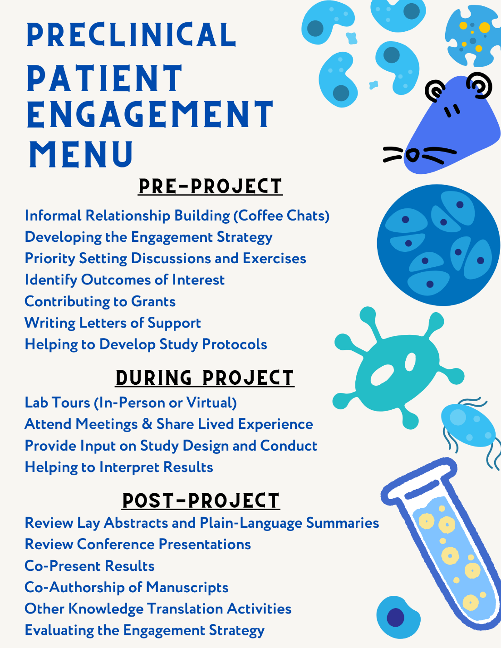

- Logistics and Planning
- Length of the Patient Partnership, Frequency & Logistics of Meetings: This section should outline the planned/agreed upon time commitment, as well as the overall length of the project. For example this may include outlining the planned frequency of meetings, or number of hours per month, how meetings will be scheduled, the format of typical meetings (e.g. presentations versus discussions, software used), how agendas will be generated, who will take and share meeting minutes, and procedure for non-members to join meetings. It can also be helpful to note that patient partners may take a step back from the partnership whenever needed.
- Orientation/Training: Can describe whether the team has an orientation session, process or training to onboard new team members in place.
- Sharing of Information and Resources: Outline plans for communication and sharing of documents (e.g. email or a cloud-based storage). Describe expectations pertaining to confidentiality and how issues will be addressed.
- Compensation & Acknowledgement: Describe how patient partners will be acknowledged and/or compensated for their time; this may include how compensation will be determined (i.e. specific guidance such as the SPOR Evidence Alliance Patient and Public Partner Compensation Policy and Protocol), frequency, form and considerations (Canadian Institutes of Health Research Patient Partner Compensation Guidelines). We strongly encourage teams to offer compensation, however if this is not possible, the team should be transparent about this and consider other ways partners may be acknowledged.
- Reimbursement of Expenses: Describe how costs incurred by patient partners to attend meetings, take part in activities, etc. will be reimbursed (i.e., parking, transportation, accommodations, hospitality, printing). Describe information regarding how eligible reimbursement expenses will be shared (e.g. upon invitation to a meeting).

- Accountability and Evaluation:
- Point of Contact: This section can outline the main point of contact for patient partners. It can also be helpful to include an organizational chart outlining the team structure in the appendix.
- Reviewing/Revising the Terms of Reference: Outline planned frequency to review the terms of reference (e.g. annually, when a new team member joins, or another predefined interval), and who will be involved in the review.
- Evaluation of the Patient Engagement Strategy: Can outline plans for collecting feedback and areas for improvement from all members of the team (and frequency). May consider the use of existing tools, such as the Public and Patient Engagement Evaluation Tool (PPEET survey) or others (Centre of Excellence of Partnership with Patients and the Public – Evaluation Toolkit). Should also outline how the results will be shared with the team and how feedback will be addressed.

- Definition of Terms:
Include a glossary of technical terms commonly used in the project/across the team. The team may also offer one-on-one meetings to provide additional background information/ discussion of the project to assist in understanding of the research.

Acknowledgements/Credit: This template was developed based on NIHR (formerly NIH- INVOLVE) suggested terms of reference headers and past examples from Blueprint Translational Research team collaborations, while also drawing from other sources including [Alberta SPOR TOR template].
Appendix A: Team Members, Roles, and Contact Information
Appendix B: Version Control

